Eagle Class – Year 6 – Autumn 2025
 | 8:40  –  9:05 | 9:05 – 10:05 |  | 10:05 – 11:00 | 11:00  -  11:15 | 11:15-12:15 | 12:15  -  12:30 | 12.30  -  1.30 | 1.30 – 2.30 | 2.30 – 3.30
Monday | Reg  Fluency Task  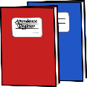 | Assembly to 9:30am | Weekly Arithmetic   | Maths  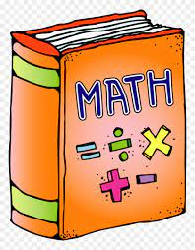 | Break | Mrs Finch  Spellings   |  | Lunch | Mrs Finch   | P.E with Adam  
Tuesday | Reg  Fluency Task | SPAG/ Reading comp  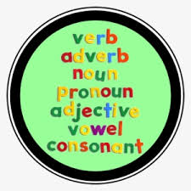 |  | Maths | Break | English | ERIC & AR Quiz Time | Lunch |  | PSHE  
Wednesday | Reg  Fluency Task | R.E   |  | Maths | Break | English | ERIC & AR Quiz Time | Lunch | 
Thursday | Reg  Fluency Task | Homework marking  ERIC & AR Quiz Time   |  | Maths | Break | English | Making Me | Lunch | Geography/History alternate  
Friday | Reg  Fluency Task | French   |  | Maths | Break | English | Making Me  Mrs Finch | Lunch | Mrs Finch:  Music   | Mrs Finch:  Art  

