SCA February 22 Newsletter | 25 02.22
Dear Families
I hope you enjoyed your half term break and it does not seem too soon until the next holiday. This term is the shortest and it can feel as though the children have no sooner come back to school than we begin staring down the barrel of Easter!

Homework

In response to your feedback we have reviewed our Homework Policy. We have tried our best to accommodate a very wide range of views and at the same time, ensure that the homework delivers its core purpose of supporting the learning in school. We will be having a workshop for parents and carers of pupils in Reception and year 1 and year 2 about the new online platform we will be using after the Easter holidays. The sessions will take place on Thursday 29th March at 3:30. In KS2 we will be introducing a new system of informing parents/carers about homework tasks called Show My Homework. We will also begin using this after the Easter holidays and more information will follow in the coming weeks, along with the revised policy.

Children’s Responses
As promised in the last issue we are sharing some of the children’s responses to our survey just to give you a flavor of how they feel. These were the most common ones.

The Things I Like About My School
When it was closed early on a Friday (lots of responses)
Swimming
School dinners
My teachers (huge response)
The big field
Having packed lunch on the field
After school club
My friends
Music
Art
When we can go on the field
My teachers are kind
The worry box
The book vending machine
I have lots of fun
I am safe
Sports and PE

My school could be better if………
It closed early on Friday again
More breaks
A pond
More playground equipment
Parents came in
More trips
More swimming
More Art
Scooters and bikes on the playground
Nothing my school is amazing!!!

Now we have to see what we can do about some of these things so watch this space.

Marley’s Story
Every now and then, someone or something comes along that really touches your heart. Around this time a year ago we had the good fortune of meeting a very special family who shared a tragic event with us.
Marley attended St Christophers and left in 2012. His mum Jennifer, explained to me that this was one of his happy places, and as a fund raising walk was taking place she asked if it could finish at our school. This was indeed a privilege and we had the opportunity to meet a great group of people who had joined together to support the Foundation described in Jennifer’s story below.
Jennifer explained how she believes that some children need an outlet that doesn’t involve talking as the main focus of therapy and that an approach such as art may be better for some children.

We would like to support this idea and the Foundation and have therefore included the information below and will be holding a non - school uniform day once a year in order to raise some funds. We will also be exploring some fund raising ideas that involve the medium or art and would appreciate any of your ideas or input for a very worthy cause.

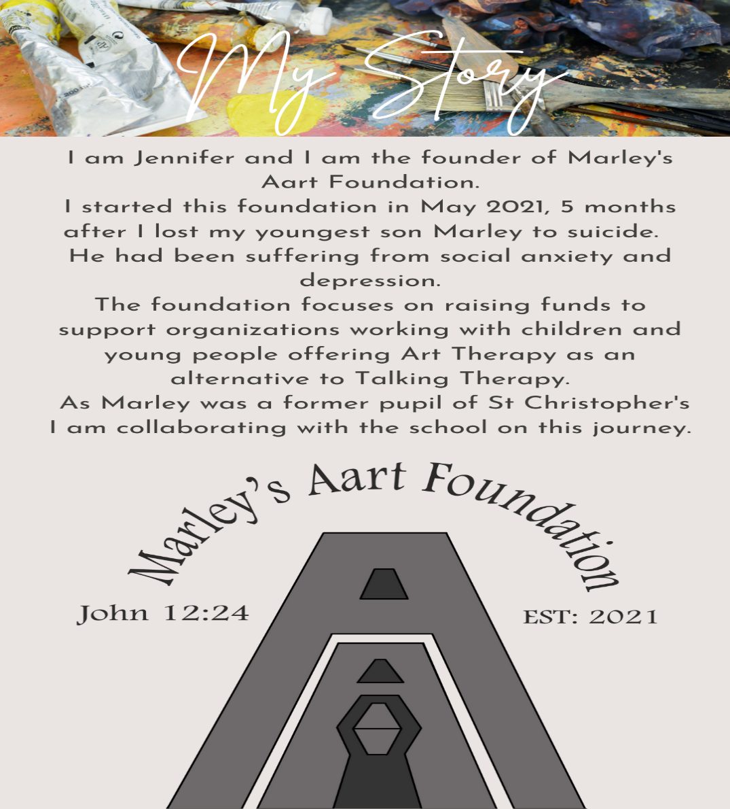

.

Governors
We are always looking to recruit more governors. If you would like to know more about the role or know anyone that would like to know more, please contact the school office for some details. We have had some interest and will be in touch those who have contacted us shortly.

Safeguarding
As you are aware, we live in a world that is increasingly online and whilst this brings many benefits to our lifestyles there are also many dangers especially to the most vulnerable in our communities which includes our children. We have been notified by the safeguarding board that there are an increasing number of cases of online grooming and we would ask you to be extra vigilant regarding your children’s use of their devices and the sites they visit.
We have an online safety programme that is active in school and there is a parent workshop on Tuesday 22nd March at 9.00 am in the hall. This will be hosted by Bedfordshire Police. An invitation will be sent out by Mrs Lay shortly on Parent Mail.

In addition to this, Mrs Lay has sent out, again by Parent Mail, a guide on online grooming and sites to be aware of. The following websites also provide some very helpful information.

https://saferinternet.org.uk/guide-and-resource/parents-and-carers https://www.nspcc.org.uk/keeping-children-safe/online-safety/

Please check that you have updated Parent Mail with your most up to date contact details.

BASC

As many of you are aware, we have a very popular before and after school club! Although we do take late bookings, could I just remind you to book as early as you can to avoid disappointment.

Please let us know if there is any other information you would like included in your newsletter. We are very happy to include community events where appropriate.

Upcoming Dates

Class Photos 28th March
Year 3 and 4 visit to the Think Tank 2nd March
World Book Day- 3rd March
4GK Class Assembly 14th March 2:30pm
Science Fair 16th March 1:15pm onwards
Online Safety Workshop for parents 22nd March – 9.00am (invitations will be sent by Parent Mail – see above)

Parent Consultations 22nd and 24th March. (Pre School, YR and KS1 and KS2)
Parent Engagement Session- New Homework – 29th March
Rocksteady Music Concert- 30th March 9:00 am
End of the Term- 1st March

.

