Year 1 Home Learning Tasks for 13th July 2020
Please see below for Learning Tasks that your child could complete this week. The children can complete them in their red homework books, on paper or on Purple Mash. If you have any problems then please feel free to email Mrs Hart.
English | Maths | Other Subjects
Phonics – Log into the Phonics Play website. https://legacy.phonicsplay.co.uk/#  Username = march20  Password = home  Click on Phase 5 on the left hand side . Can you complete some of the games and activities?  Can you complete the daily English lessons on the Bitesize Home Learning website? https://www.bbc.co.uk/bitesize/dailylessons  Look at the writing prompt pictures and questions below. Think about the question and discuss your answers with someone in your house.  Can you write your answers in sentences?  Don’t forget to use capital letters, full stops and try to include some adjectives. | White Rose Maths  Please complete this weeks Maths lessons.  https://whiterosemaths.com/homelearning/year-1/  Can you complete the daily Maths lessons on BBC Bitesize?  https://www.bbc.co.uk/bitesize/dailylessons  Can you complete the Maths challenges below?  Practice counting in 2’s, 5’s and 10’s. Write down your numbers. Can you find the related division facts?  https://www.bbc.co.uk/bitesize/articles/z6dr92p  https://www.bbc.co.uk/bitesize/articles/zkvhscw | PE- Rolling Penalties https://www.youthsporttrust.org/sites/default/files/Home%20PE%20Rolling%20Penalties.pdf  Three in a row  https://www.youthsporttrust.org/sites/default/files/Home%20PE%20Three%20in%20a%20Row.pdf  Challenge: Can you create your own Sports Day at home?  Mindfulness and Wellbeing Activities –  Butterfly week with The Mindfulness Project  https://www.youtube.com/watch?v=Wm2w2ubk4Qw  Science – Can you find out about the Human Body and our senses? Use this website to help you.  https://www.bbc.co.uk/bitesize/articles/z8xjr2p  Challenge: Draw a picture for each of your senses and label them. Make a list of things that you can see ,hear, touch, taste and smell.  Computing- Can you create a poster to show how to keep safe online?  https://www.bbc.co.uk/bitesize/articles/zr3bhcw  Art  Can you complete some of the art activities below?  Cloud and Sky Art  Shadow Art  Purple Mash – Please log into your Purple Mash account to see a range of tasks which have been set for you, which you could complete.

Maths Challenge 1 | Maths Challenge 2

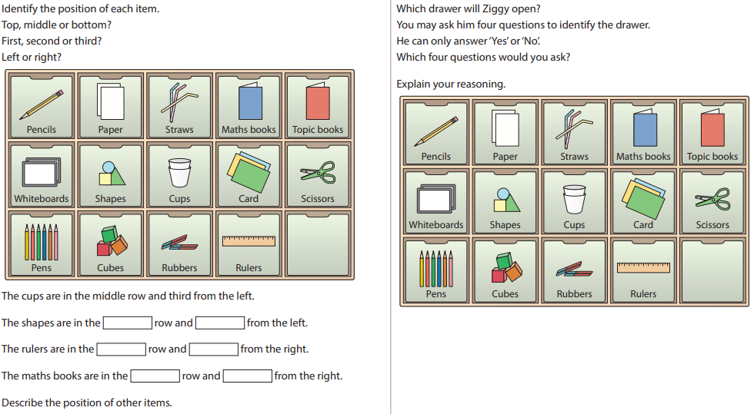

Writing Prompts
