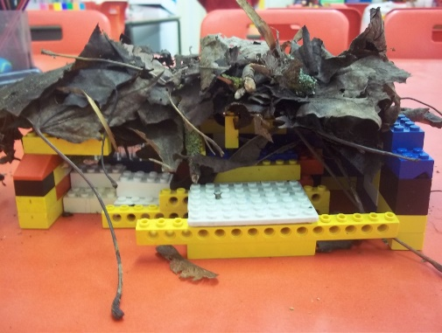
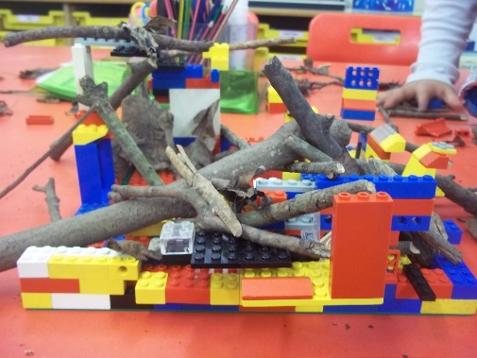
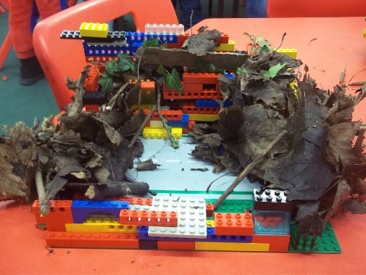
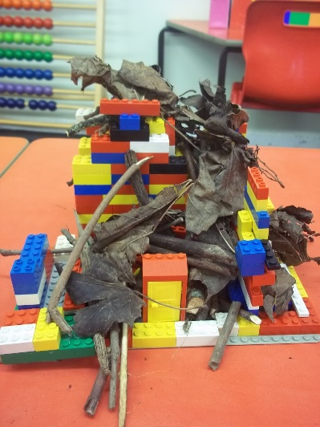
In RE, we have been learning about Sukkot. Sukkot is a Jewish celebration where Jewish people remember and show thanks for God protecting them under difficult conditions. We read the story behind Sukkot and in particular focused our learning on a special shelter made from natural materials called a ‘Sukkah’. We learnt about how Sukkah’s are made, how they are decorated inside and what Jewish people do in them. We then went outside to collect natural materials such as sticks, leaves and twigs and used these to create our own Sukkah’s. We did some great teamwork

