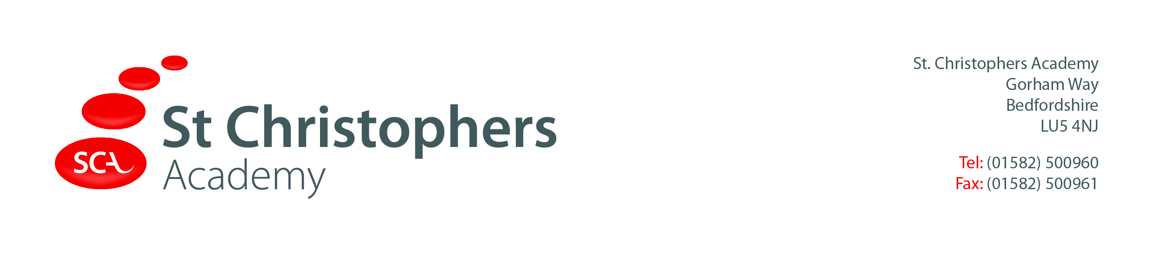

Dear Parents/Carers,
As part of our history work this term on Nurses, we have invited History off the Page to provide an in-school workshop about Florence Nightingale on Tuesday 21st March 2023.
On the day your child will find out what it was like to have been a nurse during the Crimean War in 1854. They will take part in lots of hands on, practical activities and will be able to keep the things that they make.
Your child may dress up for the day if they wish, see ideas for costumes below.
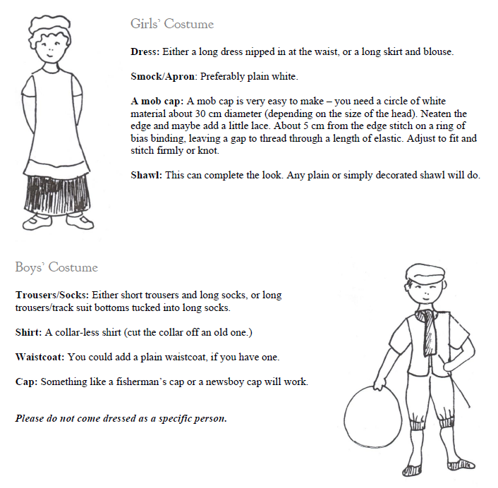

We will also need some helpers on the day to support the activities taking place. If you can help please let us know.
A contribution of £5.00 per pupil is requested (cash or bank transfer (A/C no 81050962 sort code 30-99-83, St Christophers Fund Account), this is to cover the cost of the experience. If your child is in receipt of Free School Meals or you are experiencing any financial difficulties or wish to discuss payment please speak with the school office staff. Monies to be paid by Friday 17th March 2023
Thank you for your ongoing support,
Year 2 Team.

